Instructions:

This handout is just for practice. It is the responsibility of the student to attend class to mark their own work in class when your professor takes up this exercise. You are NOT required to hand this practice sheet into your professor (keep it for future practice).
The answers to this handout will NOT be posted or emailed to students.
- List the number of digits for the following numbering systems:
  - Decimal
  - Binary
  - Octal
  - Hexadecimal
- Write a simple chart to show which values are represented for letter A - F
for a hexadecimal number.
- How many binary digits does 1 octal digit represent?
- How many binary digits does 1 hexadecimal digit represent?
- Use manual numbering conversion to complete the table displayed below.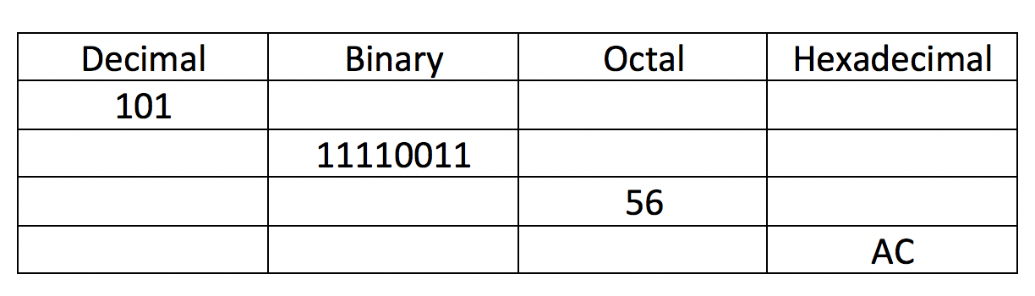
- Write the chmod command (using the symbolic method) to set “pass-through” permissions (eg. r w x - - x - - x) for your home directory using an absolute pathname.
Also, write a Linux command to verify that permissions where set.
- Perform a binary to octal numbering conversion for the permissions: r w x - - x - - x Write single Linux command to set “pass-through” permissions for your home directory but use the absolute method (i.e. octal numbers).
- Write a single Linux command to add read permissions for same group members for the ~/tests directory. Use the symbolic method.
- Write a single Linux command to remove write permissions for same group members
and other group members for the ~/projects directory. Use the symbolic method.
- Write a single Linux command to set the permissions for the ~/assignments directory
to the following using the absolute method (i.e. octal numbers): r w x r - x - - x
NOTE: Show your work to perform a binary to octal conversion.
- Assume that you just issued the command:
chmod u=rwx,go=x ~/linux/content
What would be the new permissions for the ~/linux/content directory?
- Assume that you just issued the commands:
umask 077
mkdir mydir
touch mydir/myfile.txt
What would be the permissions for those newly created directory and regular file?
(show your work)

