INSTRUCTIONS:
These are practice questions to act as a rough review for the ULI101 course.
NOTE 1: These questions DO NOT represent the layout of your online final exam.
Your instructor will take up these review questions in Week 13.
NOTE 2: Your instructor will NOT post answers in MS Word document
(but the lesson will be recorded for remote delivery classes).
QUESTION LAYOUT:
PART A M/C, M/A
PART B MATCHING
PART C LINUX COMMANDS
PART D REGULAR EXPRESSIONS
PART E SCRIPTING

PART A – M/C, M/A
Each question has 1 correct answer. Circle the letter of each correct answer on this exam paper. For questions that contain the text “Select all that Apply”, treat as a multiple answer question.
- Which command will copy the file /bin/ls to your home directory,
assuming that you just logged in? (Select all that Apply)
a. copy /bin/ls /
b. cp /bin/ls .
c. cp /bin/ls ~
d. copy /bin/ls ..
- Which command will move a file called /public/abc.txt, to your current directory?
a. mv /public/abc.txt ~
b. move /public/abc.txt .
c. mv /public/abc.txt ..
d. mv /public/abc.txt .
- Which command will give the same results as chmod 755 ?
Assume that you do not know the current permissions of the file (Select all that Apply)
a. chmod a+777
b. chmod u+rwx,go+rw
c. chmod u=rwx,go=rx
d. chmod u+7,go+5
- Which command will display a “/” after directory files, and an “*” after executable files?
a. ls -l
b. ls -R
c. ls -i
d. ls -F
- Which is the octal value of the file permission: rwxr-xr-- ?
a. 755
b. 754
c. 751
d. 741

- Which of the following key combinations will erase the previously typed word when typing a Linux command?
a. crtl d
b. ctrl e
c. ctrl u
d. ctrl w
- The ls –l command displays file and directory information in several columns. What is the meaning of the first (left-most) character in the display?
a. type of file or directory
b. owner of the file or directory
c. always '-' to line up other columns correctly
d. permissions of the parent directory
- Which of the following ENVIRONMENT VARIABLES will display a series of directories that the shell will check in order to run a Linux command?
a. PS1 b. HOME c. DIR d. PATH
- Which of the following can be used to separate a Linux command from an argument and an argument from another argument? (Select all that Apply)
a. space b.;
c. tab d.,
- Which of the following Linux pipeline commands is invalid?
a. grep “the” myfile | ls | more
b. ls | grep “the” > file2
c. head -25 | more < file1
d.ls | sort | tail -30 | more
- Which command will allow pass-through permissions for your home directory? Passthrough permissions allow full permissions for the owner, and read and access permissions for same and different group members.
a. chmod 744 ~
b. chmod 700 ~
c. chmod 711 ~
d. chmod 720 ~

- Which command will display your current working directory?
a. dir
b. pwd
c. ps
d. ls -p
- Which command will run the shell script called myscript.bash for the first time
(in the background)?
a. ./myscript.bash &
b. bg myscript.bash
c. myscript.bash %
d. ./myscript.bash | bg
- Which of the following Linux commands will create the file abc.link which shares the same i-node as the file abc.txt?
a. ln -s abc.txt abc.link
b. ln -s abc.link abc.txt
c. ln abc.link abc.txt
d. ln abc.txt abc.link
- Which hexadecimal number represents the octal number 36?
a. 2
b. 2F
c. 1E
d. C
- Which vi command will move the cursor to the end of the file?
a. m$
b. ESC
c.G
d.$
- You have sftp'd to Matrix from your PC at home.
Which command will copy a file called file2 to Matrix?
a. scp . file2
b. put file2
c. scp file2 .
d. get file2

- What is the value of the exit status variable assuming the previous command executed properly?
a.1
b.2
c. 0 (i.e. zero)
d.T
- Which of the following filenames represent a hidden file?
a. myfile
b. .myfile
c. myfile.hidden
d. ~myfile

PART B – MATCHING
Match the Description with the most appropriate Command shown below - write the Command Code in the appropriate column following the example shown.
Note: Not all commands will be used, but a particular one can be used only once.
The First answer is for example purposes.
Letter | Description Command | Command
D | Display current time and date. | A. thumb
 | Display last lines of a file. | B. device link
 | Get user input from standard input. | C. symbolic link
 | Display the type of a file, based on contents. | D. date
 | Display a message. | E. diff
 | Which link can be created across file systems? | F. echo
 | Display values of all variables currently set. | G. file
 | The kind of link that affects the link count | H. finger
 | Display online manual information about a command. | I. head
 |  | J. kill
 |  | K. hard link
 |  | L. man
 |  | M. ps
 |  | N. pwd
 |  | O. read
 |  | P. set
 |  | Q. tail

PART C – LINUX COMMANDS
All answers are based on the partial tree diagram shown below. You can assume that your username is jenny and your current (and home) directory is /home/jenny. You have been given complete permissions to joey's home directory all of his files and subdirectories.
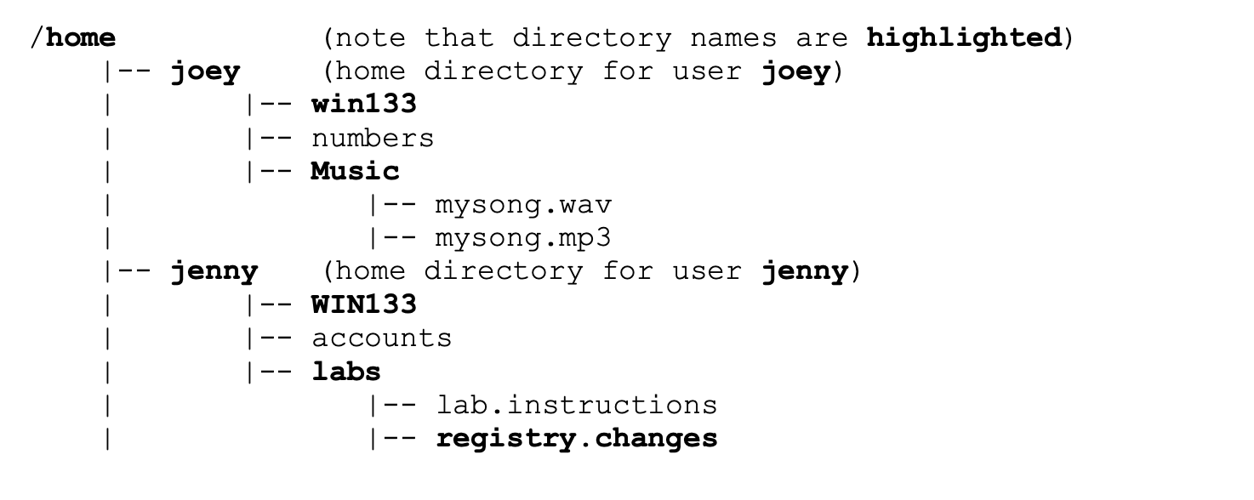
- Write a single Linux command to remove the labs directories and its contains. Use absolute pathnames. (2 marks)
- Write a single Linux pipeline command to take all lines in the file lab.instructions that match the pattern test, and and append only the last 5 lines into the existing file called accounts. Use only relative pathnames. (2 marks).
- Write a single Linux command to rename the file accounts to myaccounts. Use only relative-to- home pathnames. (2 marks)
- Write a single Linux command to list all processes that are currently running the background. (1 mark)

- Write a single Linux command to create three subdirectories under Jenny's (your) home directory: - uli101 (contained in your home directory)
- work (contained in the uli101 directory)
- assignments (contained in the work directory) (2 marks)
- Write a single Linux command to create an empty file in joey's home directory called me.txt Use a relative-to-home pathname. (1 mark)
- Write a single Linux command to move the directory called registry.changes to the WIN133 directory. To answer this question, use one absolute pathname and one relative pathname. (2 marks)
- Write a single Linux command to run the ls abc.txt command and throw any standard output (stdout) to the “garbage-can”. If the previous “ls” command worked, display on the screen yes, and if the previous “ls” command didn't work, display on the screen no . (2 marks)
- Write a single Linux command to display a calandar for the year 2012. (1 mark)

PART D – REGULAR EXPRESSIONS 5 MARKS
Answer all of the following questions in this section.
1. If you want to find all occurrences of . (dot) in the data contained in fileA, what is the
grep expression?
2. Look at the following grep expression: grep -i “[a-c].*[^0-9]$” fileA
Which of the following statements is not true?
- The line can only start with a, b, c or A,B,C
- The line cannot end in a number
- The line can be any length in terms of number of characters on the line
- iv. The line can end in any character other than a number
- What command will you use if you had to cut 3rd and 5th fields from fileA
- Write the regular expression that will match any blank lines in fileA
- write the regular expression that will find a string that has a number followed by a percent sign.

PART E – SCRIPTING
Here is a listing of the script myscript:
#!/bin/bash
echo “let's go”
if [ $# -gt 2 ]
then echo -n "hello"
echo “there”
exit 1 fi
for items in $*
do
echo $items
done
echo “game over”
Assuming this script is located in your current directory with the appropriate execute permissions, display the result upon entering each of the following:
./myscript dog horse cat bird
./myscript pencil eraser
./myscript

